Elixir

Smart Irrigation and Agriculture System

User Manuel

*This manual can be used for Elixir Portal version 1.0.0 and newer.

Contents

1. General features 3

1.1. Access to Interface 3

1.2. Login 3

1.3. User Profile 4

2. Dashboard 6

List of Figures

Figure 1: Login Page 3

Figure 2: Login Panel 4

Figure 3: Access to Account Details 4

Figure 4: Options in Account Details 5

# General features

## Access to Interface

Elixir is a web-based application. It can be accessed from <http://elixirapp.live/>

*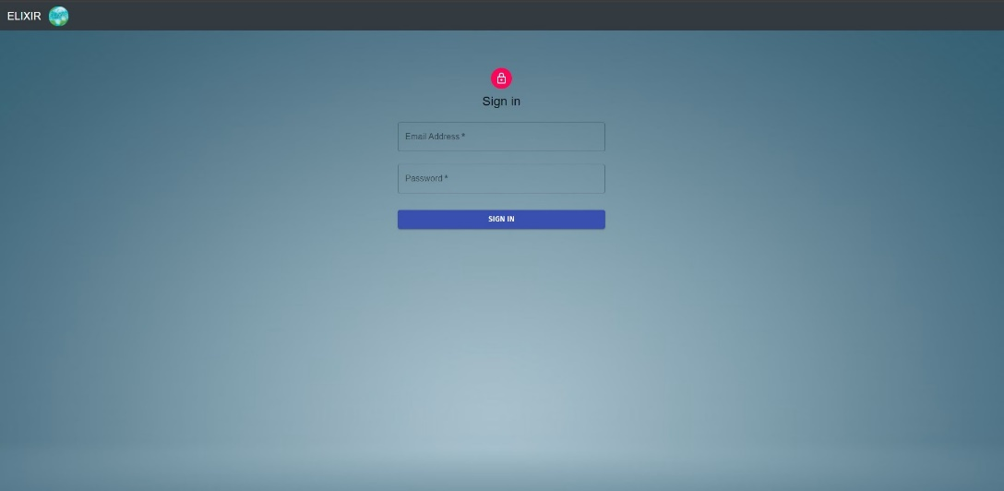Note: The browser recommended for Elixir is Chrome and Firefox, and the screen resolution is 1920 * 1080.*

Figure 1: Login Page

## Login

The user must enter their **Username** and **Password** and click the **Login** button to access Elixir

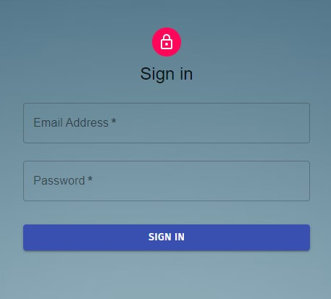

Figure 2: Login Panel

If the wrong **Username** or **Password** information are entered an error message will be given.

## User Profile

To access the user profile page, use the Change Account Details option located in the upper left part of the navigation bar. Then click to access it.

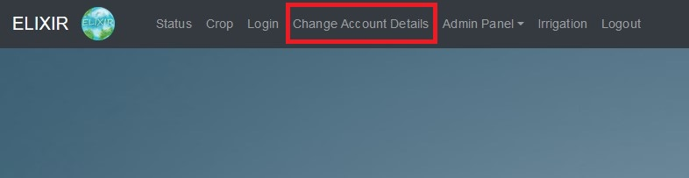This section has two options **Change Email** and **Change Password.**

Figure 3: Access to Account Details

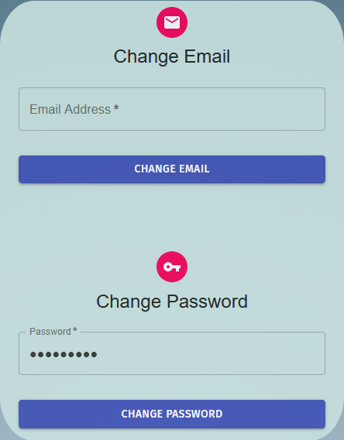

Figure 4: Options in Account Details

The user can change his/her password within this panel. To do this, enter the new password in the **New Password** fields. In order to change the password, the following criteria must be met:

* Password must contain at least 8 characters.
* Password must contain both numerical and alphabetical characters.

If these conditions are met the user will be able to change their passwords by clicking the **Change Password** button.

The password is not updated in the following situations and the user is warned:

* The new password does not meet the requirements.

# Dashboard

TO BE UPDATED